Table of Contents
- INTRODUCTION 2
- STP of Marketing 2
2.1 Segmentation 2
2.2 Targeting 3
2.3 Positioning 4
- Product Features 4
3.1 Features and value 4
3.2 Customer needs 6
- Pricing 7
- Promotion 8
5.1 Channels 8
5.2 Strategies to encourage purchase 9
- Place 10
- Services Supports 10
- Conclusion 11

Table of Figures
Figure 1 1
Figure 2 2
Figure 3 3
Figure 4 3
Figure 5 5
Figure 6 5
Figure 7 5
- Introduction
In today's world, many families have both spouses working to meet the demands of living in these challenging times. Consequently, with changing social influences and evolving lifestyles, the habit of eating at home has been on the decline. It has become common for many people to dine out, even during special holidays, as today’s families often find cooking at home to be cumbersome. Another reason driving this new habit is that people tend to enjoy eating outside their homes, finding joy in exploring diverse culinary offerings and experiencing different atmospheres. This growing demand has led to a vast array of dining establishments, each striving to provide unique and memorable experiences to their patrons.
The rise of numerous restaurants highlights the competitive nature of the culinary industry. To stand out and deliver exceptional dining experiences, chefs must rely on their expertise and the quality of their tools. Among the most crucial tools in a chef's arsenal is a good knife. A high-quality knife is essential for precise cutting, efficient preparation, and ensuring the best possible texture and presentation of ingredients. This is why the right knife can significantly enhance a chef's ability.
Chefs are continually pushing the boundaries of culinary innovation. They understand that to achieve excellence, they need to equip themselves with top-tier tools. A sharp, reliable knife not only aids in the cooking process but also reflects the chef's commitment to quality and craftsmanship. In this dynamic food culture, the combination of skilled chefs and superior tools ensures that the joy of eating out continues to flourish.
- STP of Marketing
2.1 Segmentation
- Demographic
Figure 1: Singapore Ethnic
Distribution

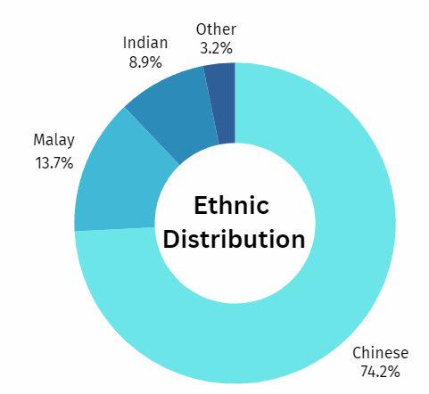
Demographic segmentation is based on measurable characteristics of populations such as gender, age, income, education, occupation, and ethnic. Figure 1 showed that, Singapore is a multicultural country with Chinese as their major ethnic, followed by Malay, Indian, and other ethnic. Since our groups choose Singapore as our target country, we choose to use Chinese Ethnic as our demographic segmentation.
source: statista.com
- Behaviour
Figure 2: Knife; Tim Hayward
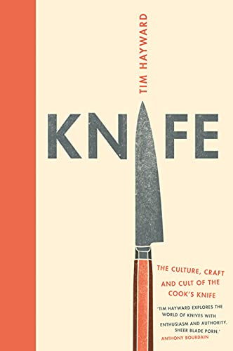
Behavior segmentation focuses on how frequently people buy and use a product, including the quantity and intensity of use. For our segmentation, we classify regular users based on their usage patterns, specifically identifying those with high usage rates. Given that knives are essential kitchen tools, our primary focus is on heavy users—those who use knives daily. These users prioritize functionality, versatility, and sharpness in their knives, as these factors significantly impact their cooking experience. As Tim Hayward, author of "Knife," notes, "A good knife will transform the way you cook." By catering to the needs of these heavy users, we can ensure our products meet the demands of those who rely on knives the most in their culinary activities.
source: amazon.com
2.2 Targeting
Based on the results of segmentation research, Singapore's population comprises a diverse array of ethnic groups, with Chinese making up the majority at 74.2%. This demographic composition has a significant influence on the culinary landscape of the country, resulting in over 35% of all restaurants in Singapore (total recorded: 5,424 restaurants) being Chinese cuisine establishments. The demand for Chinese culinary products and tools in this market has been steadily increasing, driven by the continuous opening of new Chinese restaurants.
Based on the segmentation, the targeting will be focused on "chefs of Chinese restaurants", this indicates that a substantial portion of the population frequently dines out and prefers Chinese cuisine, which often involves intricate and precise cutting techniques, a high-quality knife is essential for achieving the desired texture and presentation of dishes, making it crucial for these restaurants to maintain high standards to attract and retain loyal customers. The role of the chef becomes even more critical in Chinese food restaurants since they must rely on their expertise and high-quality tools. Among these tools, a good knife is indispensable. A sharp, reliable knife not only aids in the cooking process but also reflects the chef's dedication to their craft and commitment to quality. This is particularly important in Chinese cuisine, where the skillful use of a knife can significantly enhance a chef's ability to prepare dishes that stand out in a crowded market.

2.3 Positioning
Figure 3: Positioning 1
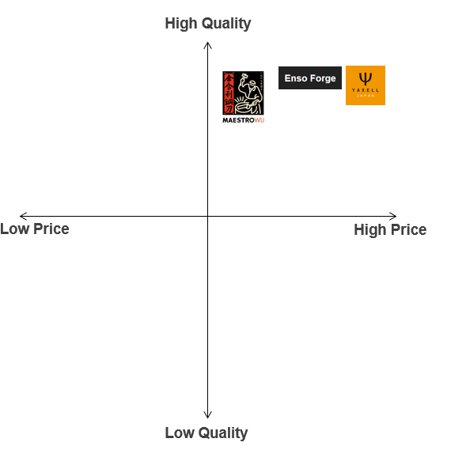
High-Quality and Affordable-Price
Figure 3 shows us that Maestro Wu offers a cheaper price despite its High-Quality. From this we can know that Maestro Wu knives offer a balance of quality and affordability while providing excellent value for the price, making them a popular choice among professional chefs and home cooks who seek high-quality knives without breaking the bank.

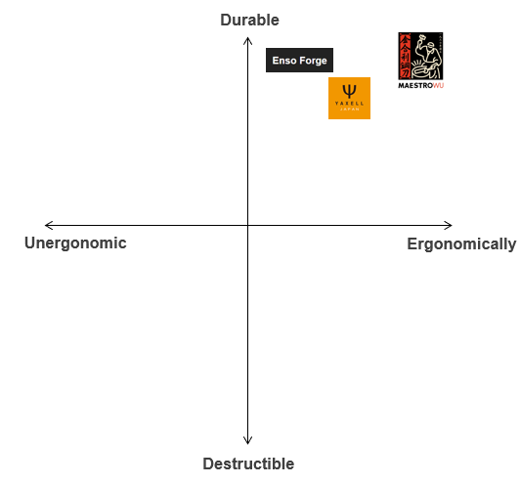
Figure 4: Positioning 2

High-Durability and Very-Ergonomically
Figure 4 shows us that Maestro Wu is designed for ergonomics and durability, providing users like a chefs with reliable tools that deliver exceptional performance and comfort in the kitchen.

- Product Features
3.1 Features and value
- Historical significance
Maestro Wu knives are made from recycled artillery shells that were fired on Kinmen during the Chinese Civil War. The island was heavily bombarded, and the locals found a way to repurpose the remnants of war into functional and high-quality knives.
Besides that, the transformation of destructive artillery shells into useful and beautiful knives symbolizes resilience and peace. It represents the ability to turn a painful past into a productive and prosperous future. These knives are a part of Kinmen's cultural heritage and reflect the island's history, craftsmanship, and ingenuity. They are a testament to the resourcefulness and creativity of the local people.
- Handcrafted (Craftsmanship spirit)
The craftsmanship spirit of Maestro Wu knives is deeply rooted in tradition, meticulous attention to detail, and the transformation of historical remnants into high-quality tools. Also, each Maestro Wu knife is individually handcrafted by skilled artisans. The process involves several stages of careful work, from forging to finishing, ensuring that every knife is unique and of the highest quality. In more detail, the blade is carefully shaped and sharpened by hand. This attention to detail ensures that each knife performs exceptionally well, with a sharp edge and balanced weight. Each knife has unique markings and patterns resulting from the forging process. Maestro Wu's knife craftsmanship passion is also characterized by an unwavering commitment to excellence. This dedication ensures that each knife is not only a testament to the past but also a reliable tool for the future.
- Knife’s Longevity / Durability
Maestro Wu knives are renowned for their exceptional durability, high-carbon steel is known for its hardness and ability to hold a sharp edge for a long time, which contributes to the knife's overall durability. This means that the blade maintains its sharpness longer and requires less frequent sharpening compared to softer steels. With proper care and maintenance, these knives can provide reliable performance and longevity, making them a valuable tool for both professional chefs and home cooks. With Rockwell Hardness (RC) rating between 58 and 60 show how meticulous forging and heat treatment processes they undergo. This hardness level ensures that the knives can handle a variety of kitchen tasks efficiently while maintaining their performance over time.
- Ergonomically design
The ergonomic design of Maestro Wu knives focuses on providing comfort, control, and efficiency for the user. The handles of Maestro Wu knives are designed with a comfortable grip in mind which is made from bakelite and special wood like sandalwood, which can add a sophisticated and luxurious aesthetic to the knife, and also provide a comfortable feel and a secure grip during cutting. The shape and texture of the handles provide a secure, non-slip grip, even when the handle is wet or greasy.
- Words customizing
Maestro Wu offers a unique customization service for their high-quality knives, allowing customers to engrave words, names, or special messages up to 20 words on the knife blade or handle. Various fonts and styles might be available to tailor the engraving to your preferences. This can be particularly appealing for creating personalized gifts or commemorating special events.
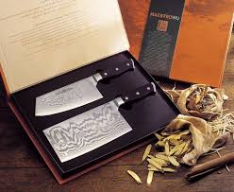
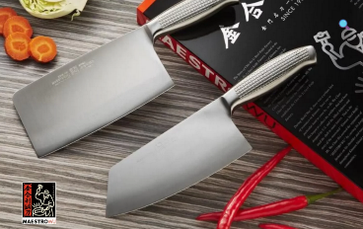
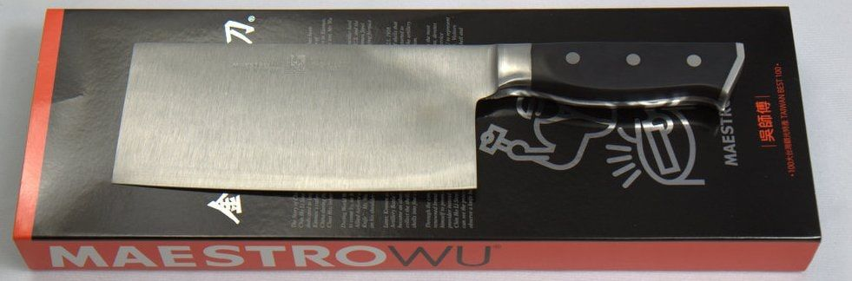
Here are several types of Maestro Wu chinese knife:
Damascus Vegetable and Meat Cleaver Set can handle almost any cutting task of any size in the kitchen. The vegetable cleaver is used for preparing vegetables and boneless meats while the meat cleaver easily chops through chicken, pork, beef and fish bones.
source: maestrowu.com
Figure 7: Maestro Wu A3
source: maestrowu.com
A knife which can chops any bones into bite-size pieces. This knife also allows you to cut, chop and slice vegetables and boneless meats with ease. These iconic knives for cooking Asian cuisine,
The iconic knife that professional Asian cuisine chefs use almost exclusively. It is designed for slicing and chopping vegetables and boneless meats. The large flat blade is used for smashing garlic and for scooping up the cut food.
source: maestrowu.com
Figure 6: Maestro Wu F-1
Figure 5: Maestro Wu D-10
3.2 Customer needs
Usually, most knife companies often receive several complaints from customers, some of which include uncomfortable handles, place to store the knife, sharpening tools (because their knife not sharp enough), rusty/corrosion problem, and the problem of maintaining knives sharp, etc. but Maestro Wu addresses common complaints about knives with a focus on quality, craftsmanship, and thoughtful design.
- Uncomfortable Handles: with a strong emphasis on ergonomic handle designs that fit comfortably in the hand, reducing strain and fatigue during use. they also use high-quality materials for the handles to ensure a comfortable grip and durability.
- Storage Solutions: they offers knife blocks and sheaths to provide safe and convenient storage options, protecting both the knife and the user. They might also provide magnetic strips for wall-mounted storage, keeping knives easily accessible and securely stored.
- Sharpening Tools: by including sharpening tools or offering it as part of their product line, ensuring customers have the means to maintain the sharpness of their knives. They could also provide professional sharpening services or detailed instructions on how to sharpen their knives effectively.
- Rust/Corrosion Problems: uses high-quality, corrosion-resistant steel in their knives to prevent rust and ensure longevity. They also provide clear care instructions to help customers maintain their knives, such as proper cleaning and drying techniques to avoid rust.
- Maintaining Sharpness: The knives are designed to retain their sharp edge for a long time, reducing the frequency of sharpening needed. Maestro Wu advises regular maintenance practices, including honing the knife with a steel rod between uses to keep the edge aligned.
By focusing on these areas, Maestro Wu ensures their knives not only meet but exceed customer expectations and address common complaints with effective solutions!
- Pricing
- We choose the Market Skimming strategy because our products offer high quality and advanced technology suited for the high-end market in Singapore. By initially setting a higher price than the other ordinary brands, we aim to maximize profits from early adopters willing to pay a premium for quality. This approach allows us to quickly recover research and marketing costs while establishing a premium image and enhancing brand value.
- We opt for the CIF(Cost, Insurance, Freight) price term. This means the seller is responsible for transporting the goods to a specified port in Singapore and covering the freight and insurance costs during transit. Choosing CIF enables us, as the buyer, to understand the total cost of importing the goods before they arrive, ensuring transparency and control over our financial planning and logistics operations.
- We decided to charge 300 SGD. According to our research, high-end knives generally range from SGD 300 to SGD 405 or may be above in Singapore. In our strategy, we set a price ceiling and a price floor.

- Price Ceiling
We would set the price ceiling at SGD 400. This setting considers the price range of high-quality knives in the market and aligns with the prices of competitors' high-end products. Such a price ceiling not only highlights the high quality and value of our products but also remains within the range that consumers are willing to pay, attracting restaurants and professional chefs who are willing to invest in premium knives.
- Price Floor
Our price floor will be based on the total product cost, including shipping and insurance, as we are using CIF (Cost, Insurance, and Freight). Assuming our production, transportation, and insurance costs total SGD 120, we will set the price floor at SGD 150 to ensure we cover all costs and achieve a basic profit. This price floor setting helps us remain competitive while ensuring the company does not incur a loss on each product sold.
This pricing strategy considers market demand and the price range of competitors while ensuring our pricing covers all costs and achieves profitability, leading to sustainable business growth and market competitiveness.
- Promotion
5.1 Channels
- Chef Associations & Culinary Events: Joining the Singapore Chef Association offers us a chance to connect directly with chefs, stay updated on trends, and build relationships in the culinary world. By becoming a member, we gains access to industry insights, showcase products at events, and collaborate on promotions. This involvement helps keep our knives relevant and competitive in the culinary market.
- Social Media: To effectively promote the Maestro Wu high-quality knife to professional chefs in Chinese restaurants in Singapore, we propose utilizing Facebook, Instagram, and YouTube. Our strategy will focus on creating high-quality posts to attract customers who value superior craftsmanship. We will produce video content demonstrating the knife's performance, durability, and unique features. Additionally, we plan to engage with chef communities to understand current trends and their specific needs. Furthermore, we will develop a high-end website to attract and convert potential customers.
- Search Engine Optimization (SEO) and Search Engine Marketing (SEM): Using both SEO and SEM will make sure more people see Maestro Wu knives online. SEO helps by making our website show up higher in Google searches, making people trust your knives more, and it's cost-effective. SEM gets your knives seen right away through ads when people search, targeting those looking for good knives, and you can see how well it's working and change it easily.
- Events and Sponsorships: Participate in or sponsor events that are relevant to your industry. This provides an opportunity for face-to-face interaction and increases brand visibility.
5.2 Strategies to encourage purchase
  - Limited-Time Offers and Discounts: Limited-time offers and discounts are one of the best strategies. By providing incentives like introductory discounts or bundle deals, Maestro Wu can encourage immediate purchases and increase customer spending. For example, offering a limited-time discount on knife sets or bundling products with complimentary items can create urgency and attract buyers. Overall, these strategies help boost sales, engage customers, and enhance brand loyalty.
- Personalized Service: Provide curated naming service, an innovative offering that allows customers to personalize their Maestro Wu knives with unique initials. This service provides a distinctive and enjoyable way for customers to customize their knives, adding a personal touch that sets their purchase apart. By offering this feature, Maestro Wu not only enhances the individuality of each knife but also provides customers with a memorable and meaningful experience. We also offer a personalized service providing a set of Chinese knives designed for various purposes.
- Exclusive Content and Educational Material: Provide exclusive content and educational materials aimed at providing valuable insights and practical guidance to our customers on how to care for their knives and more. Through a series of meticulously crafted videos and articles, we will offer comprehensive tutorials and tips on proper knife maintenance, storage techniques, sharpening methods, and other essential care practices. This initiative underscores our commitment to not only delivering exceptional products but also empowering our customers with the knowledge and resources needed to prolong the lifespan and performance of their knives. By offering this exclusive content, we aim to cultivate a deeper appreciation for Maestro Wu knives' craftsmanship while enhancing our valued customers' overall ownership experience.
- Collaborations with Culinary Institutions: This strategy is to aim Maestro Wu knives as a trend and "must-have" among chefs and aspiring chefs. Through these partnerships, we hope to aim to showcase the quality and innovation of our knives, making them preferred tools in culinary education. By integrating Maestro Wu into culinary training programs and workshops, we anticipate a rise in demand and popularity among chefs, solidifying our brand's status as a leader in premium cutlery. Working with top culinary schools like the Culinary Institute of America (CIA) in Singapore can boost Maestro Wu knives' popularity. By using our knives in their programs, future chefs will learn to trust and prefer Maestro Wu, making our knives essential tools in their careers.
- Product Demonstrations and Workshops: offering product demonstrations and workshops to show off the knives. Events That can let customers see for themselves how great our knives are - how precise, strong, and well-made they are. This aims to help customers understand what makes Maestro Wu knives special, so they can make smart choices when buying. For example, Participating in world chef exhibitions can greatly increase the visibility of Maestro Wu knives. This is a chance for us to connect directly with customers, answer their questions, and share our passion for our products.
- Place
In Singapore, land is so scarce that the rent will be very high for us to open a brick-and-mortar store. In addition, Maestro Wu doesn’t need to serve customers instantly. Therefore, the strategy will deliver the products from Taiwan based on the customer orders. After customer makes their order, the product will be wrapped by hard cardboard and bubble wrap, after that the product will be delivered by truck to the harbor, then shipping by sea, with its lower costs, is the proper way. The vessel will travel between Singapore and Taiwan frequently, so there is no need to worry about deliveries not being on time, also the logistics company we cooperate with will help us to deliver the products to their store.
- Service Supports
- Generally, chefs like to sharpen one knife against another, often called "honing," for several important reasons. Sharp knives are safer because they require less pressure, reducing the risk of slips and accidents, and providing better cutting control. In addition, sharp knives produce clean, precise cuts, which are important for cooking aesthetics and consistency, reduce damage to food ingredients, and maintain better texture and appearance. Therefore, we can provide two kinds of choices.
The “Sharpening Stone” will be the basic kind of accessory. But if customers pay more, they can get the “Honing Rod”, which aligns bent blade edges, provides fast sharpening, and saves time compared to a sharpening stone. This method is quick and easy to access in the kitchen, ensuring knives stay sharp without disrupting workflow.
- If the knives are broken, chefs need to get a whole new one immediately. Otherwise, they might have no tools to cut the ingredients and keep the restaurant working. Therefore, they are looking for shops where they can buy knives easily and quickly. For Maestro Wu, who decides to sell their products through the Internet, they must cooperate with a logistics company with high delivery speed. The knives will be sent to their store directly instead of a given place, like a convenience store. Also, the packaging material will be a cardboard box wrapped in bubble wrap which will make it hard to damage the contents and waterproof.
- In the marketplace, most of the knives are designed for right-handed individuals or both types of people. However, chefs need to use tools that are suitable for their habitual hands. Ergonomic design was created to fit the natural movements of the hand. Left-handed individuals will find it very hard to find proper products to use. Therefore, we can provide a customized service for them without creating a whole new type. By just adjusting some designs, like the angle of the knives, we can attract more people to use our products.
- Conclusion
After conducting extensive market analysis in Singapore and analyzing the STP (Segmentation, Targeting, Positioning) framework, our group has decided to target Chinese restaurant chefs as our primary market, based on several previously mentioned factors. After comparing Maestro Wu knives with competitor knives through a positioning process, we have set the product price at 300 SGD, taking into account the price floor and price ceiling. With features and qualities such as sharpness, durability, and comfort that are essential for chefs, Maestro Wu knives have proven to be the right choice. Nevertheless, a good and attractive marketing strategy is essential to entice chefs to purchase this product. Therefore, we have developed several marketing strategies based on the lifestyle and shopping habits of Singaporeans, and we aim to provide excellent service, both indirectly (such as shipping and delivery) and directly (interacting with customers), to meet both achieved and unmet user needs.

Maestro Wu 精神·retrieved·from·https://www.maestrowu.com.tw/about-brand.php
Celine·2021·retrieved·fromHow to Use Discount Pricing Strategies to Make More Sales | Envato Tuts+ (tutsplus.com)
Patrick Grieve·2021·retrieved·from https://www.zendesk.tw/blog/start-providing-personalized-customer-service/#georedirect
Jamil Ali Ahmed·2020·retrieved·fromHow Product Recommendations Can Increase Sales (cloudways.com)
Taylor Murray 2023,09,11 Honing versus sharpening a knife: What’s the difference? ·retrieved·from·What’s the Difference Between Honing and Sharpening a Knife? (seriouseats.com)
Santoku·retrieved·from·What Makes a Knife Left-Handed or Right-Handed? – santokuknives

